PROJECT REPORT
Face Emotion Recognition
Name- Abhinav Vikram Singh (S24CSEU1759)
Name- Arnav Singh (S24CSEU1770)

A report submitted in part fulfilment of the degree of BTech in Computer Science
Supervisor: Dr. SUSMITA DAS


SCHOOL OF COMPUTER SCIENCE ENGINEERING AND TECHNOLOGY
DATE – 14/11/2025

- INTRODUCTION

Facial Emotion Recognition (FER) is used to identify human emotions from face images. In this project, the FER2013 dataset is used along with a MobileNetV2-based deep learning model. The aim was to build a lightweight model that works well for real-time video or webcam use. The model was trained using transfer learning and fine-tuning to improve accuracy while keeping the system fast.

- 2. Proposed Works / Methodology
The dataset was arranged into train, val, and test folders. All images were resized to 224×224. During training, the model used optional data augmentation (rotation, zoom, shifting, flipping) whenever the --use_augmentation option was turned on.
A MobileNetV2 model (pretrained on ImageNet) was used as the base. On top of it, layers like GlobalAveragePooling, Dense(128), and Dropout were added.
Training was done in two steps:

- Initial training with the base model frozen
- Fine-tuning by unfreezing the last few layers
The model used Adam optimizer, categorical cross-entropy, and callbacks like EarlyStopping and ModelCheckpoint.

- Data structure and algorithms used

The data was loaded using Keras flow_from_directory, which reads images directly from class-wise folders. Class weights were calculated to handle imbalance in the dataset.
MobileNetV2 was used for feature extraction. Dropout layers helped reduce overfitting.
For real-time use, a Haar Cascade face detector was used to find faces quickly in webcam frames.

- Result Analysis
Key results :
Test accuracy: 70.58%
Macro F1-score: 55%
Confusion matrix: 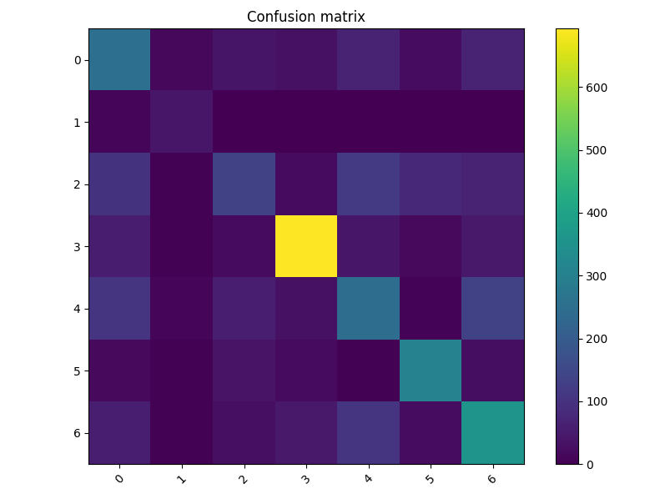

Training History :
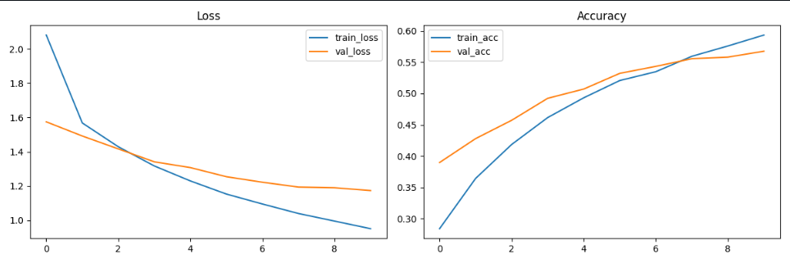

Interpretation:
The model achieved 70.58% accuracy on the test set. The macro F1-score was 55%, showing that some classes were harder for the model.
The confusion matrix shows that emotions like fear and surprise were sometimes confused with each other. The training history plot confirms that the model improved after fine-tuning.

- conclusion

Overall, the project successfully built a working FER model using MobileNetV2. The system can predict emotions in real time with good accuracy, and the final results match the expected performance for FER2013.

